Given a list of strings - List[String] (“alpha”, “gamma”, “omega”, “zeta”, “beta”)

**- find count of all strings with length 4**

*scala> var scala = List("alpha","gamma", "omega","zeta",  "beta");*

*scala: List[String] = List(alpha, gamma, omega, zeta, beta)*

*scala> var stringCnt = 0;*

*stringCnt: Int = 0*

*scala> for(s  <- scala){ if(s.length == 4) stringCnt = stringCnt + 1 }*

*scala> println(stringCnt);*

*2*

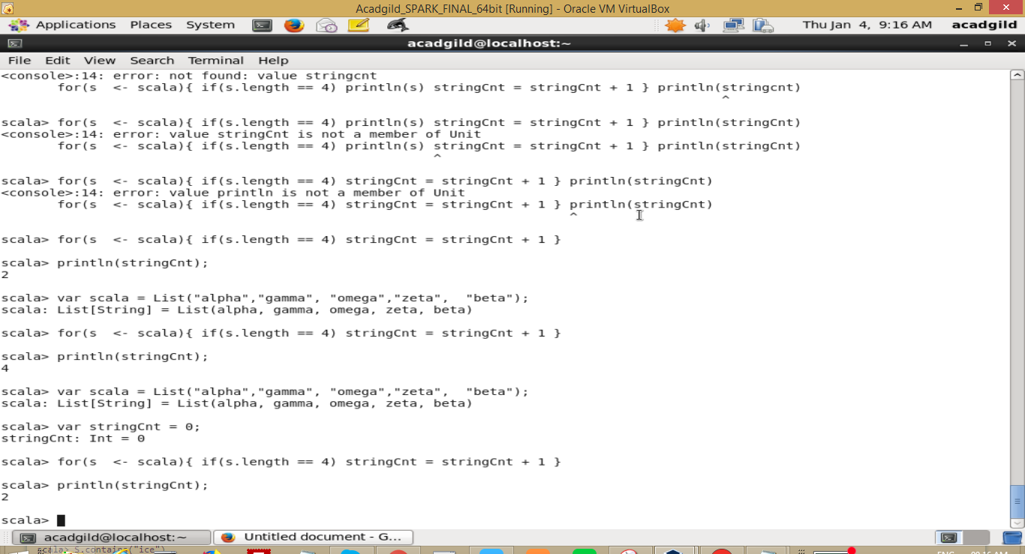

**- convert the list of string to a list of integers, where each string is mapped to its**

**corresponding length**

*scala> var scalasList = List[(String,Int)]()*

*scalasList: List[(String, Int)] = List()*

*scala> var scalas = List("alpha","gamma", "omega","zeta",  "beta");*

*scalas: List[String] = List(alpha, gamma, omega, zeta, beta)*

*scala> for(s  <- scalas){ scalasList = (s -> s.length) :: scalasList  }*

*scala> scalasList*

*res20: List[(String, Int)] = List((beta,4), (zeta,4), (omega,5), (gamma,5), (alpha,5))*

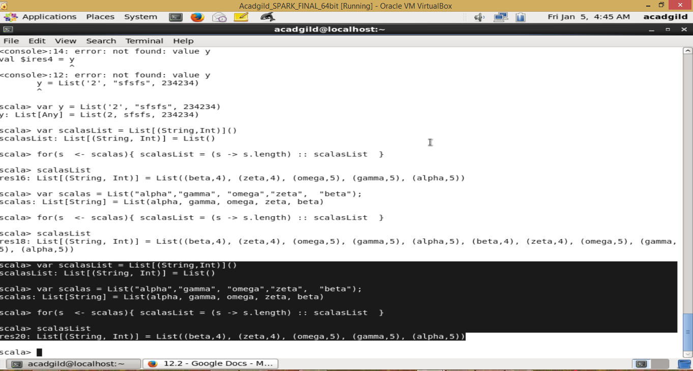

**- find count of all strings which contain alphabet ‘m’**

*scala> for(s  <- scalas){ if(s.indexOf('m') >= 0) println("string length of "+s+" which has m is "+ s.length)  }*

*string length of gamma which has m is 5*

*string length of omega which has m is 5*

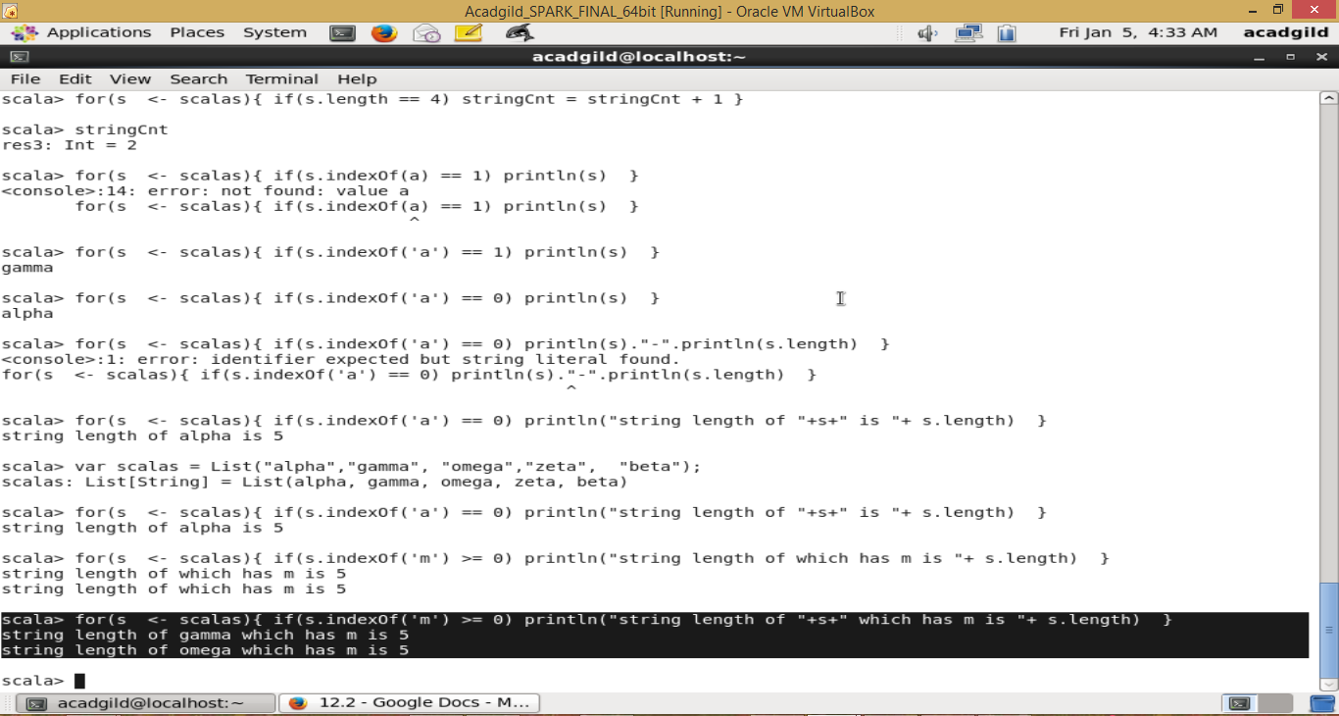

**- find the count of all strings which start with the alphabet ‘a’**

*scala> var scalas = List("alpha","gamma", "omega","zeta",  "beta");*

*scalas: List[String] = List(alpha, gamma, omega, zeta, beta)*

*scala> for(s  <- scalas){ if(s.indexOf('a') == 0) println("string length of "+s+" is "+ s.length)  }*

*string length of alpha is 5*

